Did You Know?
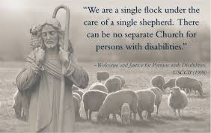
What is a disability?

From Pastoral Statement of the U. S. Catholic Bishop
On People with Disabilities

A disability is defined in the Merriam-Webster Dictionary as a physical, mental, cognitive, or developmental condition that impairs, interferes with, or limits a person's ability to engage in certain tasks or actions or participate in typical daily activities and interactions. Approximately 44–61 million people in the U.S. have a disability. In other words, 1 in 4 American adults have some type of disability and, with the aging population, the numbers of disabled Americans are increasing.
Although “people with disabilities” seem to be lumped together, they are actually a very diverse group of individuals with a wide range of needs. There are many types of disabilities in our community. Disabilities can affect an individual’s vision, movement, thinking, remembering, learning, communicating, hearing, mental health, ability to work and/or social relationships. Some of our loved ones may be affected in more than one area.
Disabilities can happen at any age. Some are, as we say born that way, such as birth defects. Some disabilities become more apparent as a child ages such as autism or learning disabilities. People may acquire a disability due to an accident. Disabilities may be associated with medical conditions such as diabetes, which can take a toll on vision, nerve damage, heart disease and kidney disease. Then, of course, as we age it gets harder to move like we use to, hearing can get difficult, driving isn’t fun anymore, especially at night, and our memories may get cloudy.
Disabilities are not scary. Most of us have at least one. Some people may be affected more than others. Individuals who have a disability are just people who may need accommodations to fully participate in life activities.
If you or a loved one is having difficulty participating in parish life here at Jesus the Divine Word Parish please contact the Everyone Belongs Special Needs Ministry and let us know how we can help because, everyone belongs here. Please look for our survey next week and or call Sue and Mike at 410-299-5192.

